Art Appreciation
EYFS | Year 1 | Year 2 | Year 3 | Year 4 | Year 5 | Year 6

Observational drawings using pencils, charcoal, crayons, pastels or pen and ink.
EYFS | Year 1 | Year 2 | Year 3 | Year 4 | Year 5 | Year 6
Self portraits | Seaside shells | Nature objects | Egyptian faces | Artefacts | Self portraits | Self portraits

Painting
EYFS | Year 1 | Year 2 | Year 3 | Year 4 | Year 5 | Year 6
Andy Warhol | Colour Chaos | The Great Fire | Pigments | Celtic artefacts | Benin kingdom | World War II

Collage
EYFS | Year 1 | Year 2 | Year 3 | Year 4 | Year 5 | Year 6
Alma Thomas | The UK | The Great Fire |  | Brooch | Cubism | World War II

Printing
EYFS | Year 1 | Year 2 | Year 3 | Year 4 | Year 5 | Year 6
 | Seaside fish |  |  | Incredible India | Navajo patterns | William Morris

Sculpture
EYFS | Year 1 | Year 2 | Year 3 | Year 4 | Year 5 | Year 6
Chouchair | Fish lanterns | Structures | Papier mache |  | Architects | Assemblage

Clay
EYFS | Year 1 | Year 2 | Year 3 | Year 4 | Year 5 | Year 6
 | Shells | Hedgehogs |  | Greek vases | Tudor Rose

EYFS continuous provision in EYFS means the children will have daily access to art materials and tools such as:
- drawing resources such as wax crayons, HB pencils, pencil crayons, chalk, felt tips.
- junk modelling resources such as: cardboard boxes, fabric scraps, foil, empty bottles or cartons, lolly sticks, corks.
- loose parts such as foam shapes, buttons and sequins
- coloured paper, white paper and craft card, clipboards, left and right-handed scissors
- joining materials such as paper clips, tack, tape, split pins, treasury tags, string, ribbon, glue sticks and PVA glue, glue spreaders and pots
- paint pots and brushes, pump bottle dispensers, water pots, paper towels, aprons, paper, easel, pegs and drying rack.

EYFS enhanced provision may include:
- seasonal materials or those related to a special festival, for example, snowflake sequins at Christmas.
- a provocation to create, for example: a daffodil in a vase with some paper, paintbrushes and watercolours surrounding it.
- materials chosen to develop certain skills or enhance an interest such as clay, papier maché or charcoal.

Enhanced provision is normally provided to either encourage consolidation of learning after a lesson, or in response to children’s expressed interests. It is normally taken away after a week or when the children are no longer using the resources.

Once a term, the children will participate in the termly whole school art weeks (see table below) where they will be introduced to the work of the famous artist outlined in the table below. During this week, the children will develop their art appreciation skills and experiment with new materials, tools and techniques.

EYFS | Autumn | Spring | Summer
Class  Topic | Space  Blast Off! | Portraits | Pirates  Ahoy!
Art  Topic | Temporary Art | Pop Art | Architecture  (Structures)
Project  Media | Collage | Paint | Sculpture
Artist | Alma Thomas  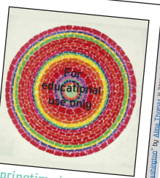 | Andy Warhol  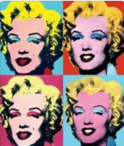 | Saloua Raouda Choucair  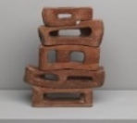
Level Expected at the End of EYFS

Expressive Arts and Design (Exploring and Using Media and Materials) Children safely use and explore a variety of materials, tools and techniques, experimenting with colour, design, texture, form and function.

Expressive Arts and Design (Being Imaginative) Children use what they have learnt about media and materials in original ways, thinking about uses and purposes. They represent their own ideas, thoughts and feelings.

Year 1 pupils should be taught:
- to use a range of materials creatively to design and make products;
- to use drawing, painting and sculpture to develop and share their ideas, experiences and imagination;
- to develop a wide range of art and design techniques in using colour, pattern, texture, line, shape, form and space;
- to talk about the work of a range of artists, craft makers and designers, describing the differences and similarities between different practices and disciplines, and making links to their own work.

Children can:
- respond positively to ideas and starting points
- explore ideas and collect information;
- describe differences and similarities and make links to their own work;
- try different materials and methods to improve;
- use key vocabulary to demonstrate knowledge and understanding in this strand: work, work of art, idea, starting point, observe, focus, design, improve.
YEAR 1 | Autumn | Spring | Summer
Class  Topic | Toys | The United Kingdom | Victorian Seaside
Name of  Art Unit | Colour Chaos  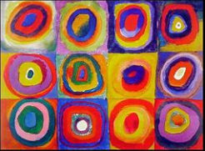 | Landscapes & Cityscapes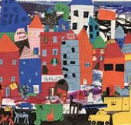 | Seaside  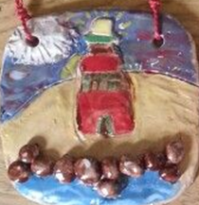
Project  Media | Paint | Collage | Sculpture  (Clay)
Artists | Piet Mondrain  Mark Rothko  Paul Klee  Jackson Pollock  Sonia Delanuay  Wassily Kandinsky | Claude Monet  Vincent Van Gogh  Jean Metzinger | Alfred Wallis
Activities | Mondrian collage  Colour mixing  Making tints  Art appreciation | Finger painting  Hot and cold pastels  Apply acrylic paint  Art appreciation | Draw fish & shells  Clay shells  Printing  Weaving  Art appreciation

Year 2 pupils should be taught:
- to use a range of materials creatively to design and make products;
- to use drawing, painting and sculpture to develop and share their ideas, experiences and imagination;
- to develop a wide range of art and design techniques in using colour, pattern, texture, line, shape, form and space;
- to talk about the work of a range of artists, craft makers and designers, describing the differences and similarities between different practices and disciplines, and making links to their own work.

Children can:
- respond positively to ideas and starting points
- explore ideas and collect information;
- describe differences and similarities and make links to their own work;
- try different materials and methods to improve;
- use key vocabulary to demonstrate knowledge and understanding in this strand: work, work of art, idea, starting point, observe, focus, design, improve.
YEAR 2 | Autumn | Spring | Summer
Class  Topic | The Great Fire  of London | Rainforests and Intrepid Explorers | Flight and Space
Name of  Art Unit | The Great Fire of London  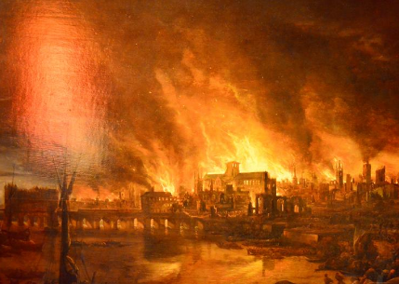 | Natural Sculptures  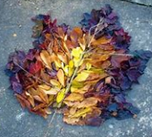 | Let’s Sculpt  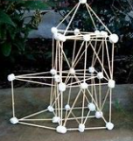
Project  Media | Collage | Sculpture  (Clay) | Sculpture
Artists | Konstantin Vasilyev  Gustav Klimt  Paul Klee  Francisco Goya  Isaac Levitan  Vasily Polenov  Nicholas Roerich  Conroy Maddox  Anselm Kiefer | Andy Goldsworthy | Marc Quinn  Michelle Reader  Barabara Hepworth  Jill Townsley  Brenda Jamison  Eva Rothschild
Activities | Charcoal drawings  Wax crayon and pastels  Painting  Paper crafts  Mixed media fire  Art appreciation | Clay hedgehogs  Nature object drawings  Temporary nature art  Big build nature art  Collage  Art appreciation | Slat dough hands  Junk modelling  Sugar cube, spoon and straw sculptures  Art appreciation

Year 3 pupils should be taught:

- to develop their techniques, including their control and their use of materials, with creativity, experimentation and an increasing awareness of different kinds of art, craft and design;
- to create sketch books to record their observations and use them to review and revisit ideas;
- to improve their mastery of art and design techniques, including drawing, painting and sculpture with a range of materials, for example, pencil, charcoal, paint, clay.

Children can:

- review and revisit ideas in their sketchbooks;
- offer feedback using technical vocabulary;
- think critically about their art and design work;
- use digital technology as sources for developing ideas;
- use key vocabulary to demonstrate knowledge and understanding in this strand: sketchbook, develop, refine, texture, shape, form, pattern, structure
YEAR 3 | Autumn | Spring | Summer
Class  Topic | Stone Age  to Iron Age | Ancient Egyptians | Marvellous Mountains
Name of  Art Unit | Stone Age  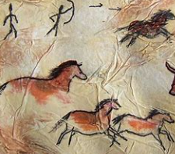 | Ancient Egyptians  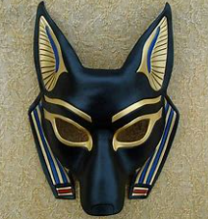 | Rocks  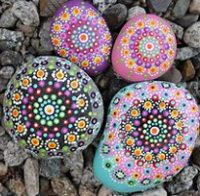
Project  Media | Charcoal and  natural pigments | Papier mache | Loose parts and  transient art
Artists | Chauvet caves, France  Santa Cruz caves, USA | Emmanuel Radnitzky | Hound Tor, Dorset  Grand Canyon, USA  Giant’s Causeway, Ireland  Mary Anning  Robert Smithson  Andy Goldsworthy
Activities | Charcoal drawings  Spray paints  Natural pigments & dyes  Clay jewellery  Art appreciation | Egyptian faces pencil, charcoal & pen  Clay faces  Papier mache masks  Art appreciation | Observational drawings  Pen and ink drawings  Acrylic paint  Temporary art  Art appreciation

Year 4 pupils should be taught:

- to develop their techniques, including their control and their use of materials, with creativity, experimentation and an increasing awareness of different kinds of art, craft and design;
- to create sketch books to record their observations and use them to review and revisit ideas;
- to improve their mastery of art and design techniques, including drawing, painting and sculpture with a range of materials, for example, pencil, charcoal, paint, clay.

Children can:

- review and revisit ideas in their sketchbooks;
- offer feedback using technical vocabulary;
- think critically about their art and design work;
- use digital technology as sources for developing ideas;
- use key vocabulary to demonstrate knowledge and understanding in this strand: sketchbook, develop, refine, texture, shape, form, pattern, structure

YEAR 4 | Autumn | Spring | Summer
Class  Topic | Romans | Incredible India | Anglo Saxons
Name of  Art Unit | Romans  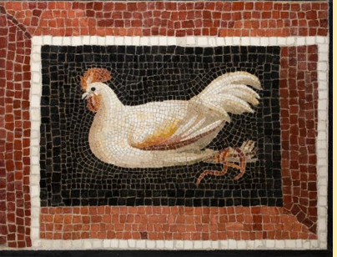 | Fabricate  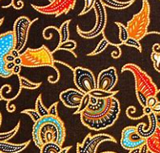 | Anglo Saxons  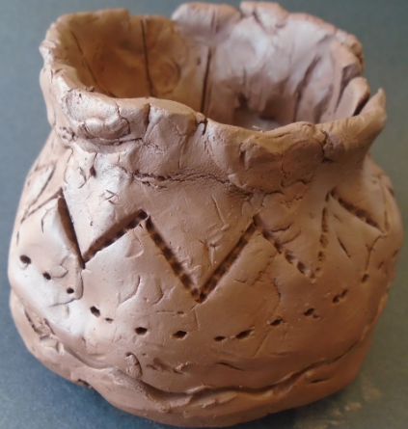
Project  Media | Mosiacs | Printing | Clay vases
Artists | Historical artefacts. | The Batik Guild | Historical artefacts.
Activities | Portrait of Terentius Neo Mosaics  Greek vases  Art appreciation | Lotus flowers (emblem) in pencils, pastels & paint  Pen and ink patterns  Batik printing  Art appreciation | Pencil and charcoal  Painting  Paper & card craft  Collage  Art appreciation

Year 5 pupils should be taught:

- to develop their techniques, including their control and their use of materials, with creativity, experimentation and an increasing awareness of different kinds of art, craft and design;
- to create sketch books to record their observations and use them to review and revisit ideas;
- to improve their mastery of art and design techniques, including drawing, painting and sculpture with a range of materials, for example, pencil, charcoal, paint, clay.

Children can:

- review and revisit ideas in their sketchbooks;
- offer feedback using technical vocabulary;
- think critically about their art and design work;
- use digital technology as sources for developing ideas;
- use key vocabulary to demonstrate knowledge and understanding in this strand: sketchbook, develop, refine, texture, shape, form, pattern, structure

YEAR 5 | Autumn | Spring | Summer
Class  Topic | Kingdom of Benin | The Americas | The Tudors
Name of  Art Unit | Cubism  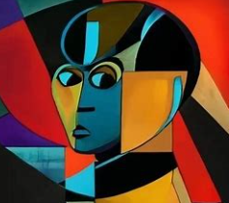 | The Americas  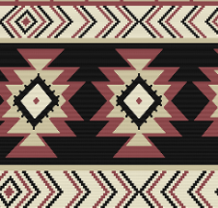 | Tudors  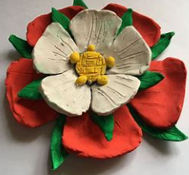
Project  Media | Collage | Printing | Clay
Artists | Pablo Picasso | Ansel Adams  Jill Townsley  Helen Frankenthaler  Frank Lloyd Wright  Mary Cassat | Hans Holbien
Activities | Pencil and charcoal  Pen and ink  Painting  Loose parts  Art appreciation | Black and white landscapes  Abstract paintings  Printing Navajo patterns  Art appreciation | Pencil, charcoal and pastel drawings  Acrylic portrait paints  Clay Tudor Rose  Art appreciation

Year 6 pupils should be taught:

- to develop their techniques, including their control and their use of materials, with creativity, experimentation and an increasing awareness of different kinds of art, craft and design;
- to create sketch books to record their observations and use them to review and revisit ideas;
- to improve their mastery of art and design techniques, including drawing, painting and sculpture with a range of materials, for example, pencil, charcoal, paint, clay.

Children can:

- review and revisit ideas in their sketchbooks;
- offer feedback using technical vocabulary;
- think critically about their art and design work;
- use digital technology as sources for developing ideas;
- use key vocabulary to demonstrate knowledge and understanding in this strand: sketchbook, develop, refine, texture, shape, form, pattern, structure

YEAR 6 | Autumn | Spring | Summer
Class  Topic | Mountains  and Victorians | Victorians | The World Wars
Name of  Art Unit | Assemblage  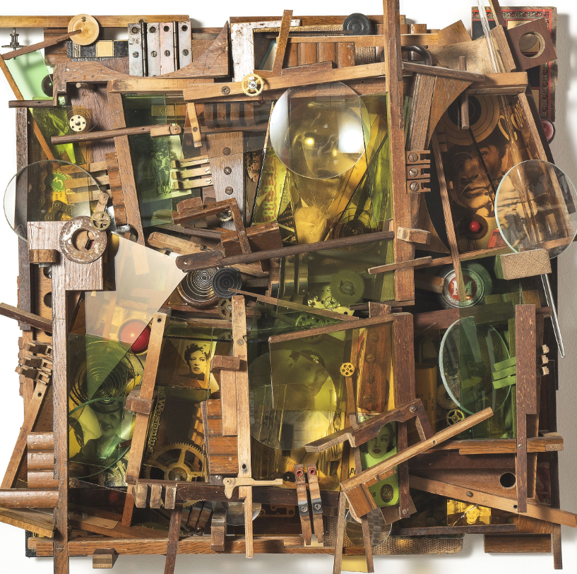 | Victorians  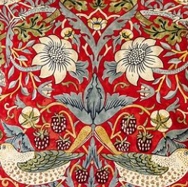 | World Wars  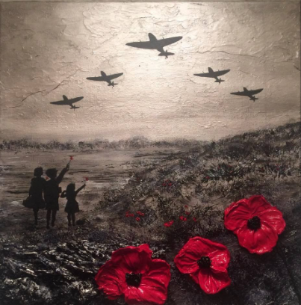
Project  Media | Assemblage | Printing | Collage
Artists | Betye Saar | William Morris | Paul Nash
Activities | Self portraits  Pencil drawings  Mood boards  Assemblage art  Art appreciation | Observational drawings of flowers and fauna  Crayons and Pastels  Fabric printing  Art appreciation | Pencil drawings  Painting  Propaganda posters  Collage  Art appreciation

