Year 3 Summer Term

Autumn Term 2011

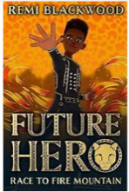
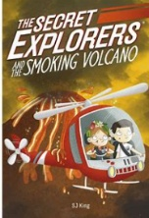

Welcome to the Summer Term!

Please sign their record a minimum of three times a week and encourage your child to note down any additional reading in their school record.

As part of our transition work preparing the children for Year 4, there will be no afternoon playtimes this term.

PE is on Wednesday & Thursday.

Homework will be set on Google Classroom on Friday.

Library will be on alternative Thursdays. Ruby will be on odd weeks and Carnelian even weeks. Please make sure the children have their books in school on these days.

Science
In the first topic, the children will identify and describe the functions of different parts of flowering plants.
In the second topic of term, rocks and soils, the children will compare and group together different kinds of rocks on the basis of their appearance and simple physical properties.
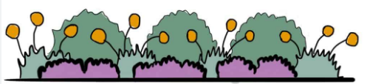

We use the Language Angels and Charanga programs to teach Spanish and Music.

Spanish

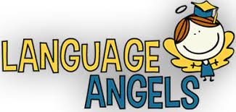

Music

Personal, Social and Health Education
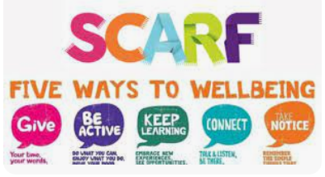
We use the online SCARF scheme to deliver our well being and PSHE sessions in class.


Religious Education 
They will discover more about Judaism, asking what is the best way for Jews to show commitment to God?
They will also discover more about
Christianity, asking why being part of a local church community is
important to Christians.

Physical Education
Wednesday – Athletics Thursday – Athletics

Maths

Following the White Rose Scheme of teaching mathematics: this first half term the children will be learning about volume and capacity, fractions and calculating money.

In the second half term, the children will be recapping the four operations, learning how to read and calculate time, understanding shape and investigating statistics.

Active Planet

This term, our topics have a geographical focus. In the first half term, the children will learn about the formation of volcanoes and where they are located around the world.
In the second half term, they will be exploring mountains across the world, learning how they are formed as well as identifying the similarities and differences between them.

English
The children will write action and adventure stories, explanation texts, recounts and persuasive letters based around this term’s Master Reader texts:
The Secret Explorers and the Smoking Volcano and Race to Fire Mountain Book 1

