WINNERSH PRIMARY SCHOOL
EQUALITIES STATEMENT – SCHOOL AND GOVERNORS
For the Academic Year 2024 - 2025

1. Introduction

Winnersh Primary School is committed to equal opportunities for all and aims to be a school where everyone:

- is respected and respects others
- takes part in the life of the school
- achieves to their potential
- develops skills essential to life
- exercises choice

We will ensure that the best education possible will be available to all pupils, irrespective of their ethnic background, gender, disability, socio-economic circumstances, religious or cultural background. We will do our best to ensure that all opportunities in our school are available to all pupils. Everyone in our school will be treated fairly and given every opportunity to participate and develop.

Our school will make sure that we know if any group is being treated unfairly or makes less progress
than others and take immediate action to rectify the situation.

Winnersh Primary School is aiming to create a diverse workforce through equitable recruitment processes. Staff and prospective staff should read this policy in conjunction with the school’s Recruitment Policy.

2. Data about the School Population and Differences of Outcome

- The school has data on its composition broken down by year group, ethnicity and gender, home language and eligibility for Pupil Premium Funding.
- The school has data on its composition broken down by types of impairment, disability and special educational need.
- The school has data on inequalities of outcome and participation connected with ethnicity, gender, disability, home language and eligibility for Pupil Premium Funding.
- The school uses data on inequalities of outcome when setting itself objectives for achievable and measurable improvements.

In addition, the governing body focuses annually on a specific area of equality, challenging and supporting where necessary.

3. Key Characteristics of Children Attending Winnersh Primary School

There are 367 pupils on roll.

 | % Winnersh Primary  (2023-2024 data) | % National  (2023-2024 data)
Boys | 50 | 51
Girls | 50 | 49
FSM | 6.9 | 25
Minority Ethnic Groups | 41 | 37
English as an Additional Language | 33.7 | 23
SEN Support | 12.6 | 13.6
SEN EHC Plan | 2.3 | 4.8
School Deprivation Indicator | 0.09 | 0.21

4. Governing Body’s Equalities Aim for the Academic Year 2024 - 2025

In accordance with our statutory Public Sector Equalities Duties, Winnersh Primary School has
adopted the following equalities objective for 2024-2025, which continues from the previous academic year.

We will:
- Scrutinise the behaviour incidents logged on CPOMS by staff to ascertain whether there are any patterns in negative behaviour amongst specific pupil groups
- Ensure that the comments submitted by staff do not reveal any bias towards a particular group or groups of pupils

We will do this by:
- Using the report functions on CPOMS to monitor behaviour incident logs
- If a pattern occurs, we will deliver learning opportunities for the children as appropriate
- Provide CPOMS training for all staff so that they know how to log incidents and how to word them so that they are neutral and non-biased

A Review of the Impact and Outcomes of our Equalities Aim for the Academic Year 2024 – 2025

We have continued to monitor and analyse the behaviour incidents logged by members of staff on CPOMS. Staff have been trained in the use of the ‘behaviour steps’, which enable incidents to be logged under specific behaviour categories. There is a Behaviour Steps Guidance document to which staff are expected to refer when dealing with and logging behaviour incidents. The document categorises examples of different behaviours, details what an adult can do in each case and the support offered. The aim of this document is to ensure that there is a consistent approach to identifying, levelling and responding to behaviour incident by providing detailed support for all staff to follow. The different behaviour steps allow the school to fully understand the types of behaviour incidents which are happening and to respond to those in a more bespoke and specific way.

Staff have also had training about how to log incidents using non-emotive, non-biased language, instead just stating the facts and quoting any relevant exchanges or pertinent language used by pupils during the incident or when talking about the incident with a member of staff afterwards.

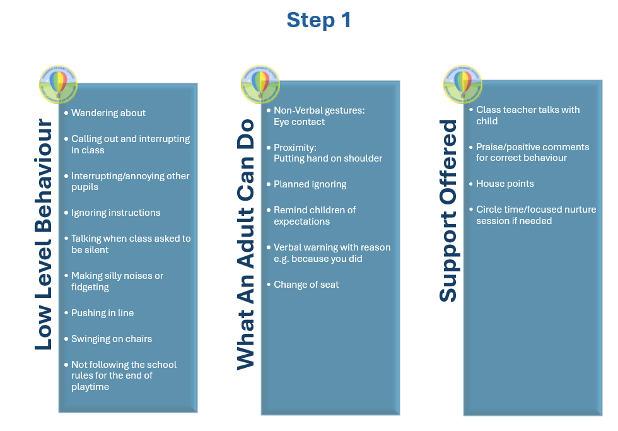

Behaviour data is collected and analysed monthly. The way in which it is presented makes it easy to interpret which behaviours are more prevalent, in which year groups and in which pupil groups. We can then target teaching, interventions or restorative activities towards those groups.

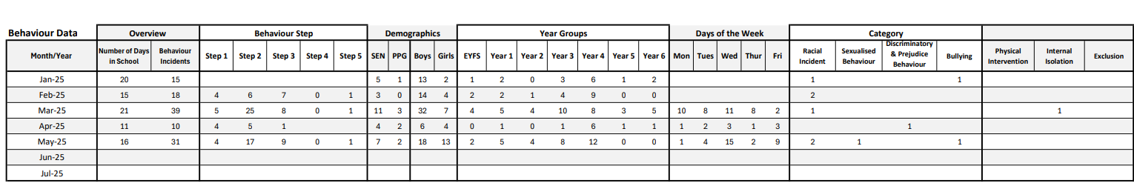

This data was presented during the recent Ofsted inspection and it supported us to talk about the behaviour incidents which have taken place, and how we have responded to them. We realise that analysing this information is good practice and we will continue to do it to support the children and uphold high standards of behaviour.

